Midterm Project Report

Name: Chen, Shih-Chia

Student ID: 50207079

* Topic: Research on image compression in the wireless network
* References:

[1] Survey of Image Compression Algorithms in Wireless Sensor Networks

[2] Adaptive Image Compression for Wireless Multimedia Communication

[3] Network Conscious Compressed Images over Wireless Network

[4] Energy-Efficient Wavelet Image Compression in Wireless Sensor Network

[5] Image Transmission Model with Quality of Service and Energy Economy in Wireless Multimedia Sensor Network

* Literature Report:

The idea to choose this topic came from the image people saw on the social network or Internet. Sometimes when people are checking out facebook or surfing on the Internet, it always needs a few seconds for the images to clearly display on the pages. Then, I came up with an idea if what factor will affect the displaying or delivering time. After narrowing my ideas, I choose to do a research on image compression in the wireless network, and start to find some related materials.

In reference [1], it mentions eight image compression algorithms. Then after evaluation, we can find out that Set-Partitioning in Hierarchical Trees wavelet-based image compression is the most efficient algorithm for the wireless sensor network and it is also simple for programmer.

First, the process of image coding can be divided into two parts, image transform (second generation) and entropy coding (first generation). In the first generation image coding, there are four image compression algorithms, JPEG, EZW, SPIHT, and EBCOT; in the second generation image compression, are pyramidal, directional decomposition, segmentation and vector quantization.

Second, analyze these algorithms by the following characteristics, processing (transforming), codebook, entropy coding, memory requirement, computation load, system complexity, coding speed, and compression quality.

Finally, based on these statistic, we can know that the most suitable for WSN is SPIHT algorithm.

In reference [2], it adapts the image compression parameters in order to deal with the wireless network difficulties, bandwidth and energy consumption. The image compression algorithm used in this issue is JPEG. It presents an approach to help choose the parameters, which lead to the optimal performance, and also meets other requirements, such as latency, bandwidth and the quality of image.

At the beginning, in order to find out how verifying the parameters will affect the energy, latency, and image quality, there are two parameters will be changed one at a time. The first parameter is the scaling of the quantization values which implements quantization in JPEG. The result shows that when the quantization level decreases, the image quality increases. However, there will be more information to transmit. The other parameter is virtual block size.

Next, presenting a methodology for low power wireless communication. There are three steps, calculate the image quality parameters tables of image quality and virtual block size, and implement on-line in the multimedia capable radio.

Finally, using the methodology to choose the optimal JPEG image compression algorithm parameters can reduce the needed energy. Therefore, the difficulties, the bandwidth and energy bottlenecks, can be overcame.

In reference [3], the topic focus on the effect of network-conscious on image compression. In order to have a better performance of transmitting the image through the network, not only reaching the minimum image size, but also the image compression algorithm should be taken into consideration.

The image compression algorithm used in this paper is based on the Application Level Framing principle. First, the image will be divided into particular pieces, application data units (ADU). In this size, each piece can contain enough information of all other ADUs. Therefore, the ADU can immediately be delivered to the receiver, without considering the order, so that this property may allow the receiver to have a faster display of images. The characteristics of this algorithm are application level framing, progressive, and robustness and adaptiveness to different user needs and various networking conditions.

It discusses the challenging parts of compressing images in wireless networks, and how to overcome it by using network-conscious algorithm. The advantage of network-conscious algorithm is the transmission control can be suitable for each ADU, which means each ADU can be transmitted based on the set of QoS parameters it associated.

By proving the correctness of these hypothesis, they develop a system to observe the result. Also, implement the network-conscious concept on two image compression algorithms, GIF89a and SPIHT.

In reference [4], due to the fact that in the wireless sensor network, there are several challenging parts such as limited bandwidth, power, storage capability, and battery constraints of the appliances, finding an energy-efficient image compression algorithm can be a possible solution. An efficient compression scheme is presented in the paper to deal with the energy issue, and at the same time, meeting the requirement of the bandwidth constraint and image quality.

In reference [5], it presents an efficient image compression algorithm in the wireless multimedia sensor network by utilizing the lifting scheme to address the SPIHT coding to wavelet biorthogonal CDF 9/7. There are two advantages that help to reach this goal. One is that it can save the energy; the other one is improvement of the Quality of Service. In order to observe how the method saves energy, there are two experiments will be conducted. First, send an original image. Second, send the compressed image by implementing this method.

* Project Plan: Take the reference [2] as a major reference, and implement the method mentioned in the paper.

The project will be divided in two parts, one is using the gray scale image and the other one is using the colorful image. Both of the images will implement the following steps.

Step1. Implement the JPEG image compression algorithm

Input image is divided into several 8x8 blocks, and each block is transformed by using Discrete Cosine Transform. Then the DCT blocks is used in the next step, quantization. After finishing quantization, we use the DCT blocks and quantization values to encode the image. Finally, we have a compressed bitstream.

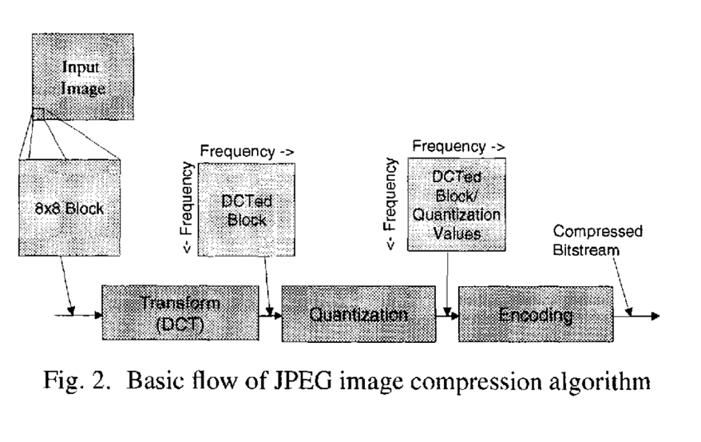 Figure 2. is from the reference [2].

Step2. Change certain JPEG image compression parameters

There are two parameters will be changed, one is scaling of the quantization value and the Virtual Block Size (VBS). In this step, we first decrease the quantization level and increase the level. Second, we change the VBS value to 8 and 5.

Then we can tell the differences between the default JPEG image compression algorithm and the adaptive algorithm.

Step3. Implement the methodology

Using the methodology presented in the paper to select the optimal JPEG image compression parameters in order to mitigate the energy consumption, so that we can still meeting the requirement of QoS (latency), bandwidth, and image quality limitation. The following are the steps of the methodology.

* Step 3.1 & 3.2: Preprocess an image quality parameters table consisting of the quantization level and compression ratio for each possible image quality and VBS.
* Step 3.3: Perform on-line in the multimedia capable radio, uses the image quality parameters table to select the optimal image compression parameters for the current latency, bandwidth, and quality of image requirements, along with the current transmission energy. Figure 6.is came from the reference [2].

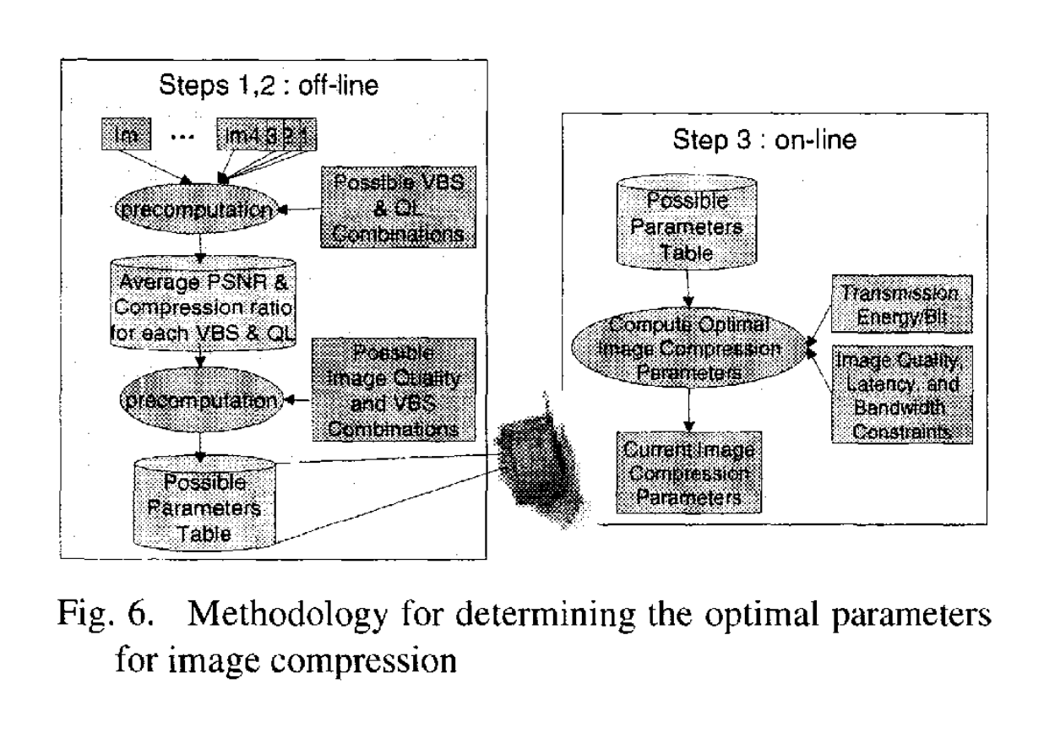

Step4. Compare the result

After finishing step 3., we get all the result. Start to analyze the differences of the original image compression and the image compression using the methodology.

The hardware needs for the project:

More than one devices that can send and receive the image from each other through wireless network.

The software needs for the project:

Library to implement the JPEG algorithm.

Matlab to analyze the image receive from the wireless network.